**Final Project Report**

PUPPY FARM WEBSITE

ZHAI, Tiange/1155129810

COMM 5961 - 2019

**Introduction**

The Puppy Farm website is a platform designed for local people who are willing to own or have already owned a dog (or more). This idea is driven by one of my friends, who is about to work in Hong Kong next year and is considering raising a dog as her companion, but she finds the procedure to own a pet very complicated and there is not a single platform existed in HK that combines the information on raising pets - information is scattered all over the Internet and she struggles to find all she needs. Thus, the concept of building a website catering for dog-owners/pre-dog-owners was formed. This report will illustrate the process of constructing a data-driven website by utilising design thinking and computational thinking methods. Stages from defining the target audience, the key problem, prototyping to testing will be explained below.

**Strategy**

*Site Objective*

Defining the site objectives was the first key thing to design a website. I did a short interview with my friend, who said a trustworthy and comprehensive platform that had all the information for raising a dog was strongly needed by someone like her, as she found she had nowhere to start to own a dog in HK. For instance, when she wanted to know the exact procedure of licensing a dog, she had to go to the HK government website to search for such information, and to learn about ‘pet stores’, she literally filtered tens (or even hundreds) of lists of information on Google Map or Facebook, without knowing which sorts of services these pet stores actually offer. For additional information, I interviewed another friend living in Hong Kong who has already raised a dog (Bichon Frise) for five years, and he told me that in the early days, when his dog needed medical treatment, he did not know which one offered the best services and he just randomly chose the one nearest (as shown on Google Map). Later, he had received recommendations from other friends and in that way, he found the appropriate ‘pet store’ that he now pays regular visits. Both interviewees have shown that there is a clear need for a website that offers the essential information for raising dogs.

Therefore, in order to help save time and efforts that dog owners/ pre-dog-owners spent on searching for relevant information, this website is considered as worth developing.

*User Needs*

This website targets two groups of audience - Hong Kong residents who have interests in raising a dog (or more), and dog owners in HK.

To further understand the needs of the two groups of audience, two group interviews were conducted. One was done with five CUHK students, who said they would be very willing to raise a dog if they settled in HK. The other was conducted with five HK friends I have known to be dog owners.

For the first user interview, five CUHK students interested in raising dogs were selected as interviewees. Three of them are females and two are males. Among them, two of them had experiences of being pet owners, and one had been raising a dog in Mainland for over ten years.

In the first user interview, I asked them two questions to understand their needs on a website about dog-raising and developed a user journey map based on such. Two key questions are presented below (see Figure 1).

|  |  |
| --- | --- |
| **Q.NO.** | **Questions** |
| Q1 | How often do you go to dog-related websites? What sorts of websites are they？ |
| Q2 | If there is a comprehensive local website about raising dogs, which types of contents and information do you expect from it？ |

*Figure 1. User Interview Question List*

For the first question, none of the interviewees said they would pay regular visits to dog-related websites, as they had not been aware that there was a website primarily about dogs. However, many of them admitted that they often browsed for dogs related contents on social media platforms, such as searching for dog videos on Youtube and dog pictures on Instagram. They also follow some accounts about dogs on Instagram and Twitter for latest updates. One of them said she sometimes went to SCPA (Society for the Prevention of Cruelty to Animals) to see if there were upcoming events about dogs taking place.

For the second question about the potential contents or information they are expecting on a comprehensive website related to dogs, interviewees revealed that they would first want to know which procedures they had to go through to gain the eligibility to own a dog. Also, many of them said it would be useful if they could find information on pet hospitals and pet hotels on the website. For amateurs on raising dogs, they mentioned that they needed to have knowledge of which types of dogs were ready for adoption before owning one.

For the second interview, five HK dog owners were selected as interviewees. Similarly, three are females and two males. Two of them are a couple. Compared with the previous group, this group of interviewees had some knowledge about dogs, but they also indicated that it would be great if the website could offer more information on dog hospitals/hotels, as the majority of their knowledge on raising pets came from their friends and their own experiences. Besides, they mentioned that they would like to have some information about special care for dogs. For instance, one talked about issues related to elder dogs, and she said information about special care for elder pets were very essential and this was a problem that every dog owner would face. In terms of the first question, this group of interviewees responded quite similarly as the previous one - they seldom went to dog-related websites, but they followed accounts about dogs on social media platforms. Also, they had closed social groups with other dog owners (e.g. Facebook groups and private Whatsapp groups), where they could share experiences on raising dogs and held events for dog owners and dogs to socialise. Thus, they also suggested that turning the comprehensive dog-related website into a forum for dog-owners to socialise would be quite useful.

According to the interviews conducted, a user journey map of the target users is developed (see Figure 2 & 3). Part of the needs of both groups of users have overlapped.

From Figure 3, it can be seen that dog owners’ needs contain two types - besides the needs of searching for information, they also expect a platform for social interaction with other dog owners，e.g. online forums/communities. Nonetheless, my current capacity does not support such function development, and thus, this part will not be covered in the final project whereas it will be left for future cultivation.

|  |  |  |  |
| --- | --- | --- | --- |
| **User Journey Mapping I** | | | |
| Persona | Stage | Goals | Artifacts&touch points |
| Pre-dog-owners | Awareness | Want to raise dogs in HK | / |
| Search | Search online | Search Engine/ Social media platforms such as Facebook |
| Browse | To learn about which types of dogs they could adopt | Dog type section |
| To learn where they could adopt dogs | Dog adoption section |
| To learn what kind of procedures they need to go through before owning a dog |
| Retain | To learn about recent activities | Upcoming events section |
| Go back to the website to check updated information | Other sections |
| When they become a dog-owner, they will go back to check other information. |

*Figure 2. User Journey Mapping (for Pre-dog-owners)*

|  |  |  |  |
| --- | --- | --- | --- |
| **User Journey Mapping II** | | | |
| Dog owners | Stage | Goals | Artifacts&touch points |
| Awareness | Want to find pet hospitals/hotels in HK | */* |
| Want to have caring information |
| Want to adopt another dog |
| Search | Search online | Search engine (e.g. Google Map)/ social media platforms such as Facebook |
| Browse | To learn about pet hospitals | Dog hospital section |
| To learn about pet hotels | Dog hotel section |
| To learn about information on caring for dogs | Tips on raising dogs section |
| To learn about other types of dogs | Dog type section |
| Interact | Communicate with other dog owners | Forum section |
| Retain | Go back to the website to communicate with others | Other sections |
|  | Go back to the website to check updated information |

*Figure 2. User Journey Mapping (for Dog owners)*

**Scope**

This section will discuss how the Puppy Farm website will help solve the problems (according to the user journey maps) and explains the scope of the contents that are needed. The website is supposed to be providing detailed and up-to-date dog-related information in an organised layout. Figure 4 shows the context diagram.

*Provide information*

*Provide information*

*Visit the website*

*Visit the website*

HK Dog owners

Puppy Farm website

Pre-dog-owners resided in HK

*Figure 4. Context diagram*

In terms of the scope of the contents, considering the user journey mapping, the information requested by the target users is categorized into five types as followed:

1. Before you adopt a dog
2. Caring for dogs
3. Dog hotels
4. Upcoming events

In details, the first section ‘before you adopt a dog’ will contain information on types of dogs and where to adopt dogs. To offer professional information, contents are sourced from professional sites, e.g. based on AKC standards. For the section ‘caring for dogs’, two primary parts are included - articles including tips for caring dogs and a map showing all the recognised hospitals in Hong Kong. The sources of articles are mainly SCPA, the Hong Kong government and Zhihu (知乎). For the map, the website has embedded a searchable map of HK01, as it is already very specifically designed, has detailed information and users can view pet hospitals by districts. For the section ‘dog hotels’, a map is designed for users to search nearby pet hotels, with detailed information of each one listed below the map. Information of dog hotels is referenced from the Agriculture, Fisheries and Conservation Department. Finally, the section ‘upcoming events’ contains information about recent activities (date, venue and the organiser(s), and the data is collected from official websites (e.g. SCPA) and over social media platforms (such as the ‘event’ on Facebooks.

**Structure**

This part of the report will explain the structure of the Puppy Farm website. To attract target users and better engage them to use the information provided, each stage of the information architecture is supposed to be logically linked to one another, with the information architecture closely following the user journey. As the primary goal of the website is to make it convenient for pre-dog-owners and dog owners in HK to easily obtain the information needed, and many of the target users may use mobile devices for searching information, the Puppy Farm website is designed to be a single-page web with a fixed navigation bar at the top - it is believed this will shorten the time of loading a new page and therefore benefits users. The site map of the website is shown below (see Figure 5).

主頁 (Home)

Requirements before sending dogs to dog hotels

Details of each dog hotel

Map showing all dog hotels

Maps showing dog hospitals

Articles containing tips on caring for dogs

Procedures of adopting a dog

Where to adopt

Types of dogs

聯繫我們(Contact)

近期活動(Upcoming events)

寄養狗狗

(Dog hotels)

狗狗保健 (Caring for dogs)

想養狗狗 (Before you adopt a dog)

*Figure 5. Site map*

The web structure attempts to match the users’ needs and expectations. Further details will be discussed in the skeleton section. Additionally, the fixed navigation bar has enabled users to reach any section, allowing the non-linear flow of information.

**Skeleton**

After mapping out the information architecture, a number of low-fidelity drafts of the website was drawn. The wireframe prototype is presented below (see Figure 6- 16).

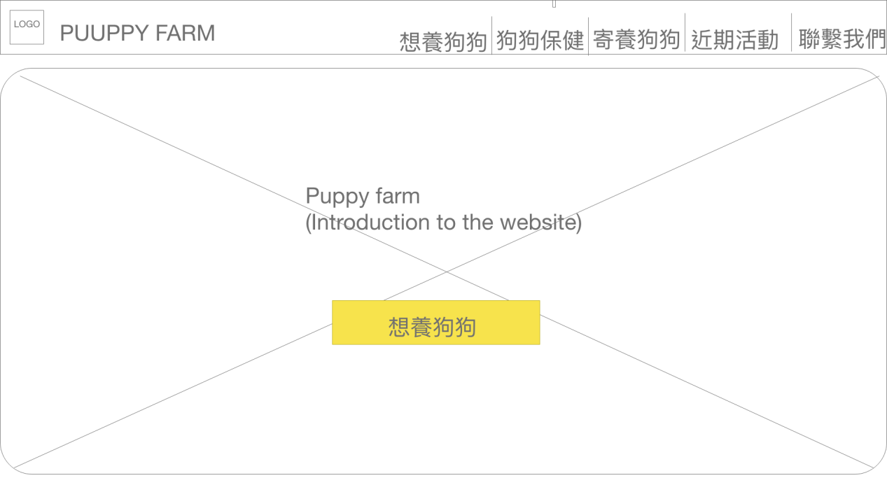*Figure 6. Homepage*

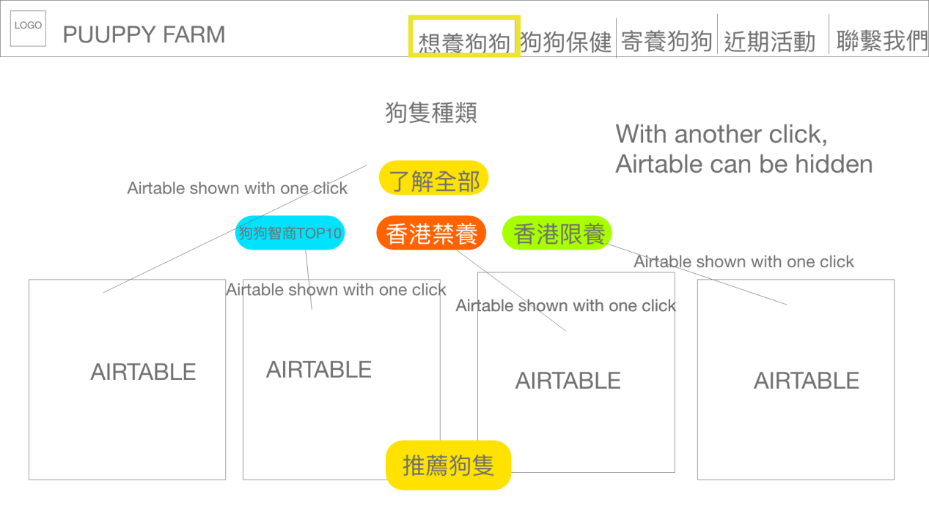

*Figure 7. Dog type page*

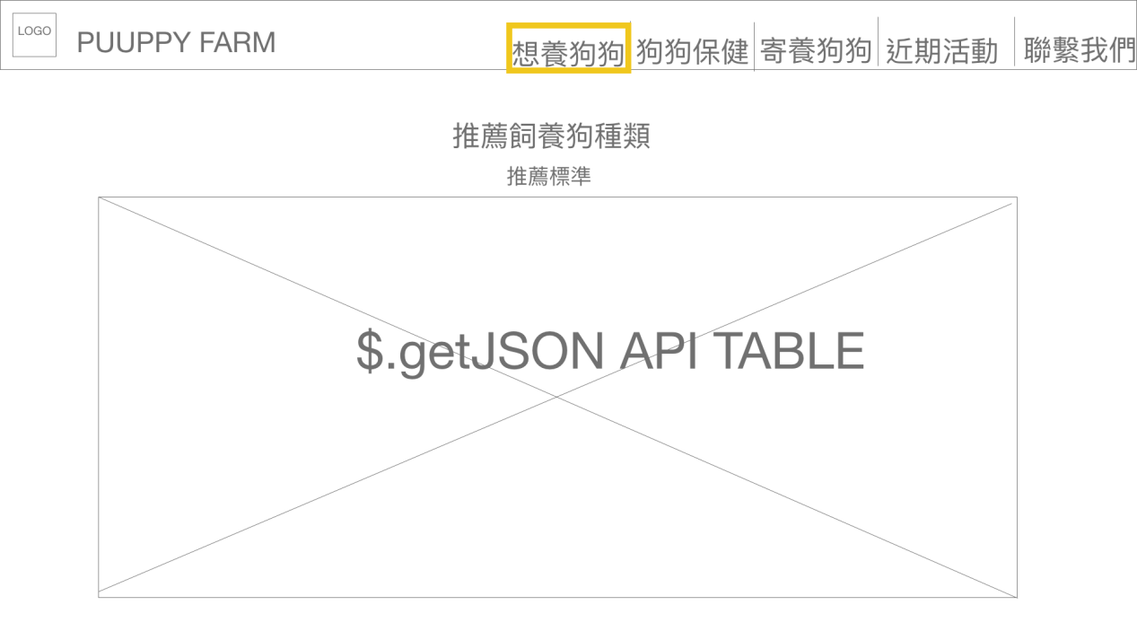

*Figure 8. Recommendation section*

*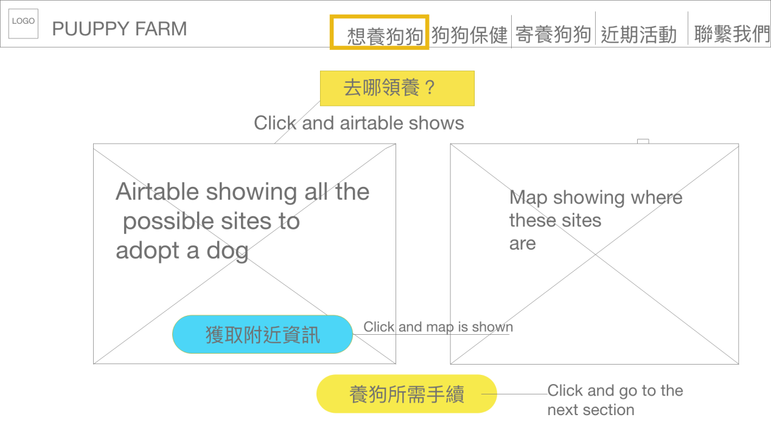Figure 9. ‘where to adopt’ section*

*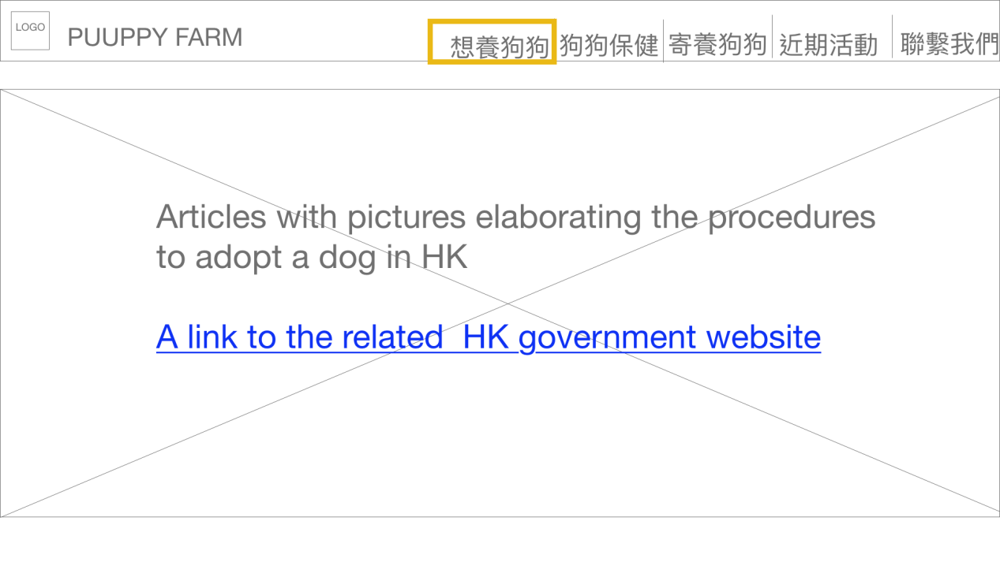Figure 10. ‘Procedures of adopting a dog’ section*

*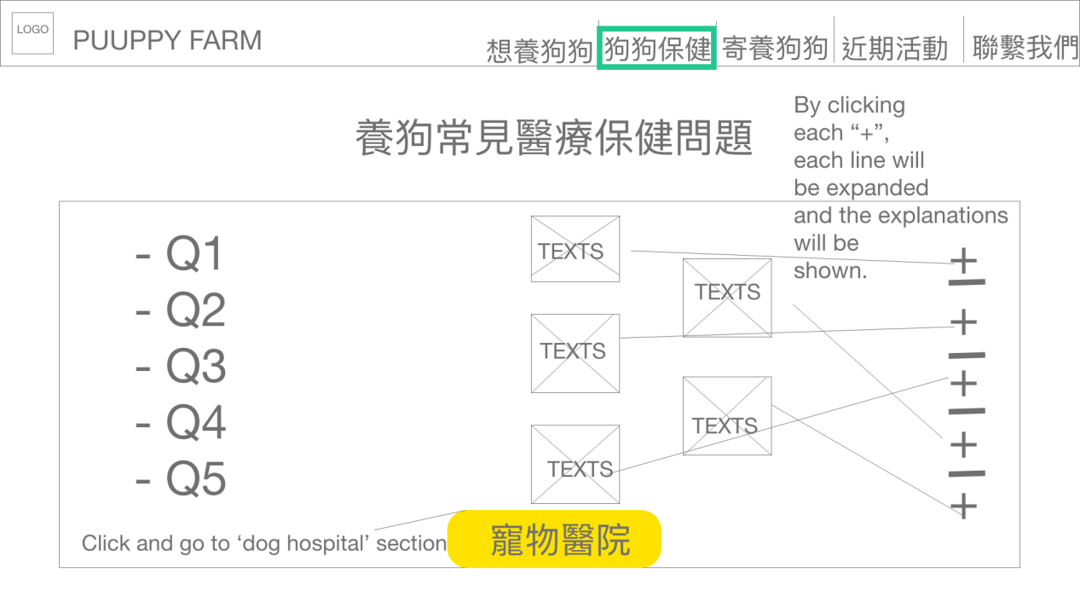Figure 11. ‘Tips on caring for dogs’ section*

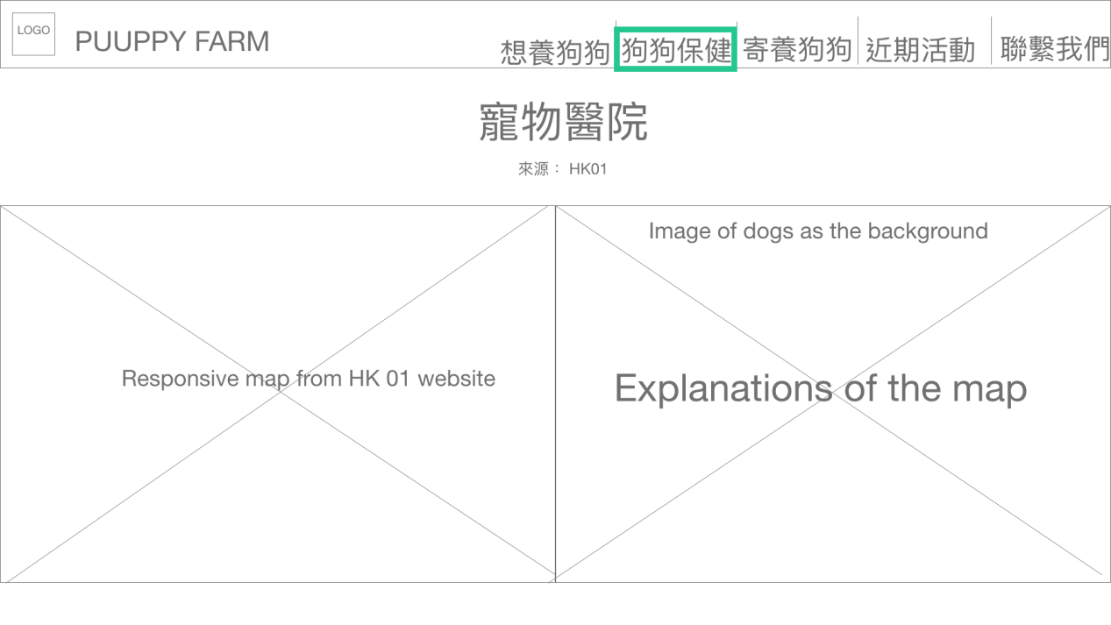

*Figure 12. ‘Dog hospital section’*

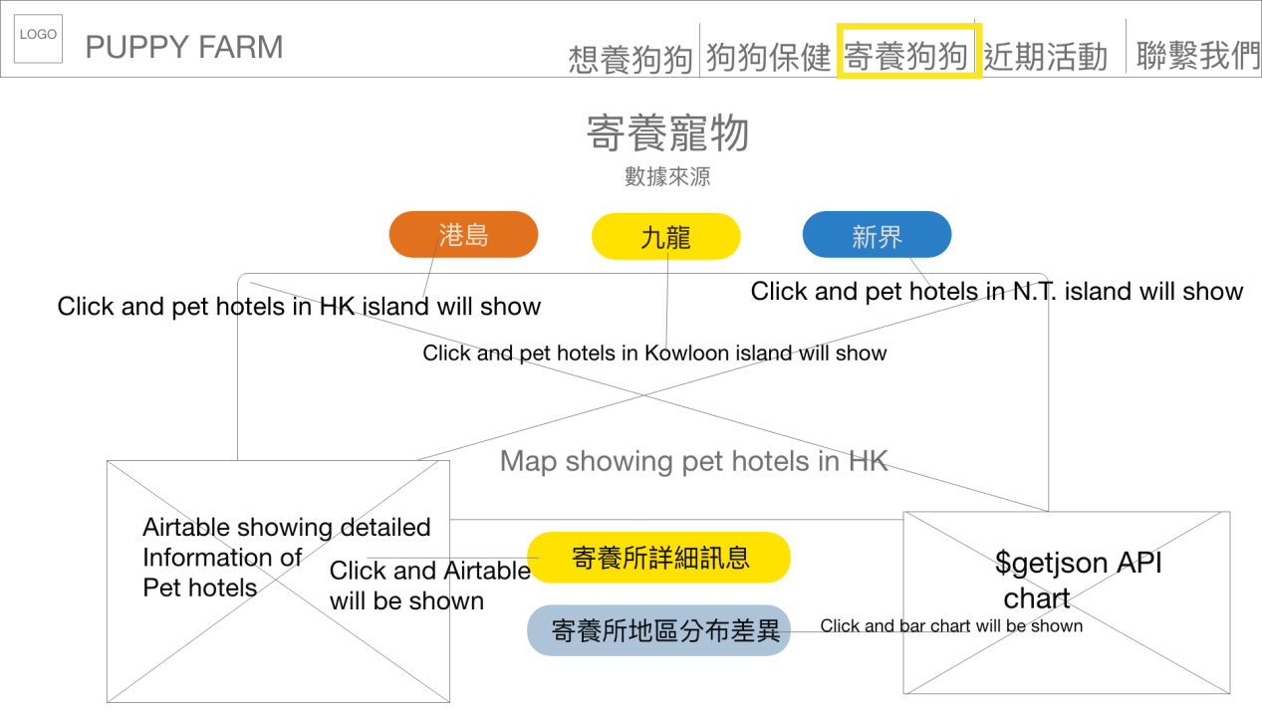

*Figure 13. ‘Dog hotels’ section*

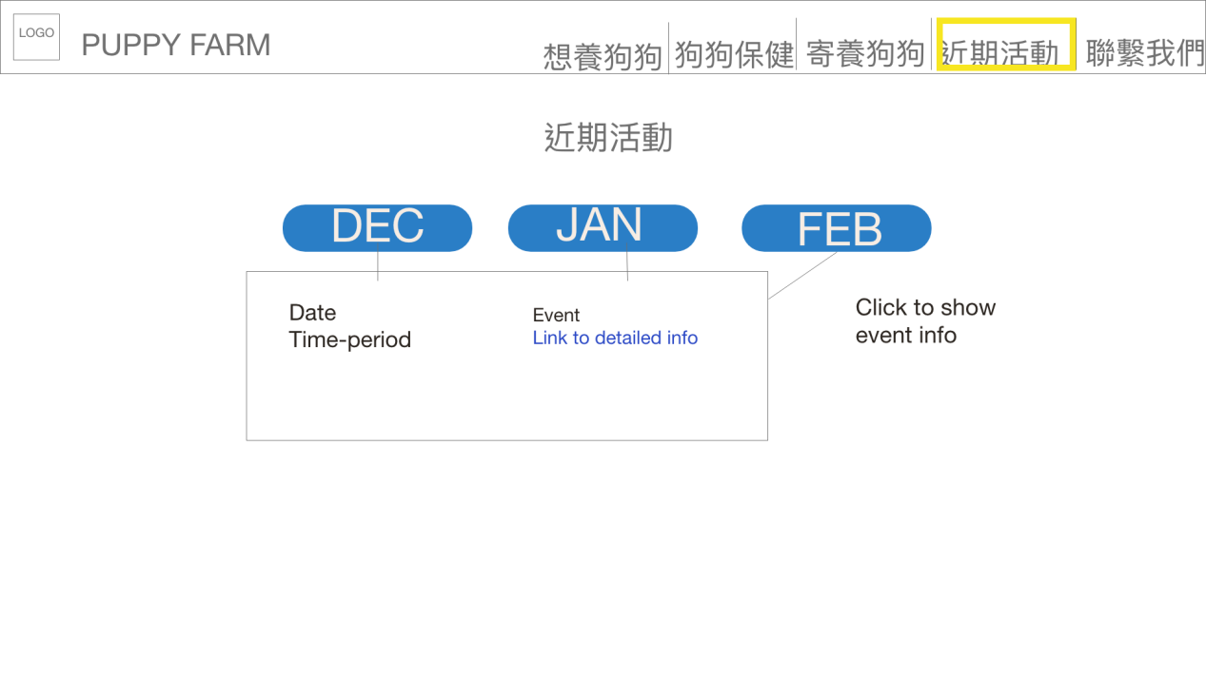

*Figure 14. ‘Upcoming events’ section*

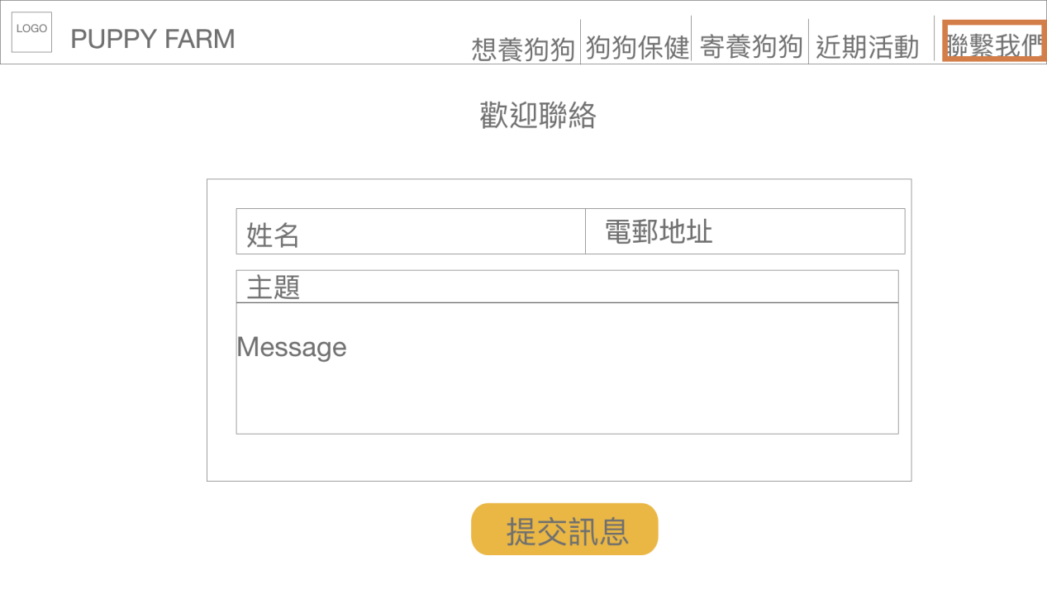

*Figure 15. ‘Contact’ section*

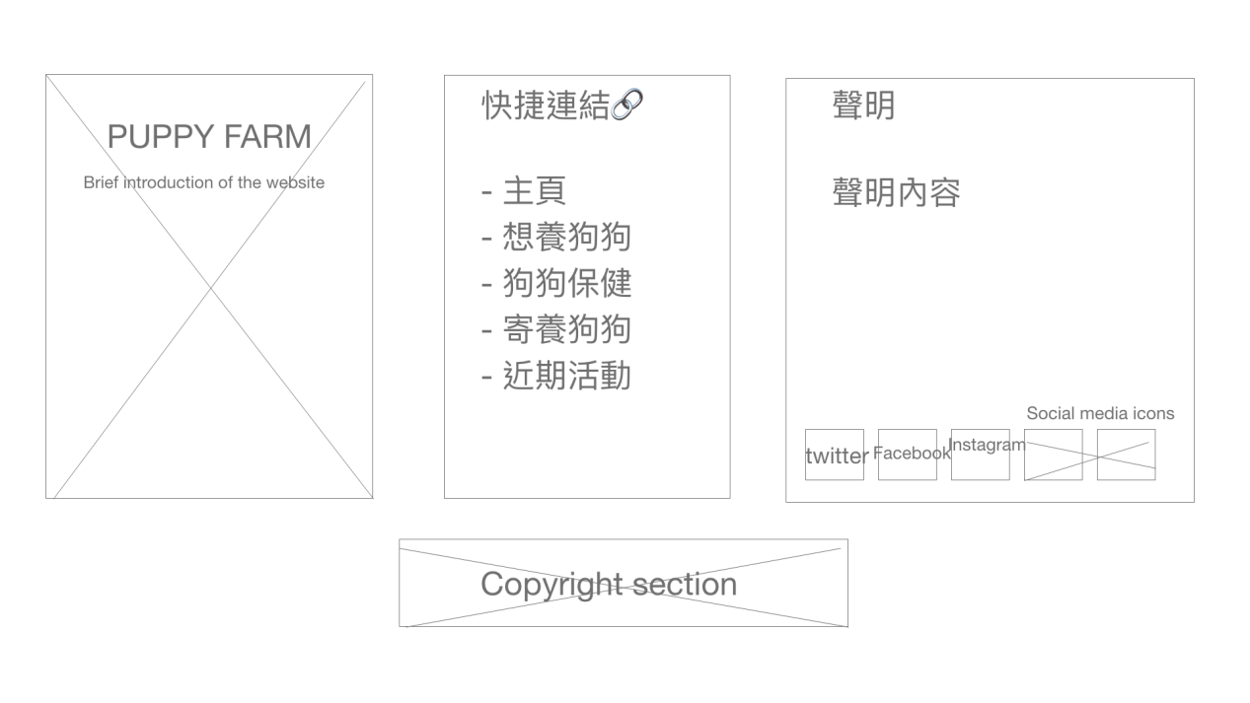

*Figure 16. Footer*

As I attempted to impress users at the very first sight of the page, I decided to cover the background with a huge image of a dog, therefore reminding users that it is a dog-related website. Above the background image, I planned to place a short paragraph explaining what this web-page is about. Below the introduction paragraph, I added a big yellow button ‘想養狗狗’(if you want to raise a dog) engaging people to click, followed by the ‘dog type’ section, where four buttons with different colours would be displayed, and by clicking each one users could view ‘all dog types’, ‘top 10 smartest dogs’, ‘dogs that are prohibited to raise in HK ’and ‘dogs that are restricted to raise in HK. If users want to see the recommended dog types for adoption, the button ‘推薦狗隻’(recommended dog types) can be pressed, leading to the ‘recommendation’ part directly. By clicking the button ‘去哪領養’(where to adopt), users could view a detailed Airtable listing all the sites and ways to adopt a dog, and by pressing the button ‘獲取附近資訊’(get nearby sites), a map showing all the sites will be displayed. The yellow button ‘養狗所需手續’(procedures required before the adoption) will lead to a brief article explaining the procedures and a URL to the website of HK government containing more specific information. The fixed navigation bar on the top right allows users to browse the website in a non-linear way. In the ‘caring for dogs’ section, the page first shows a list of potential frequently asked questions on tips about caring for dogs. By clicking on the ‘+’ sign, users could view detailed answer for each question. A button written ‘寵物醫院’(pet hospitals) leads to the next part where a map showing all dog hospitals in HK (sourced HK 01) will be shown.

The ‘dog hotels’ section primarily contains a map listing all ‘dog hotels’ in HK. Three buttons with different colours are placed above the map and allow users to search for dog hotels according to regions. The pop-up of each marker will present the image and name of the dog hotel. If users want to view detailed information certain dog hotels, they could press the button ‘寄養所詳細訊息’(detailed information of dog hotels) and an Airtable containing such contents will display. The button ‘寄養所地區分布差異’(regional differences in dog hotels) leads to the bar chart visually showing the regional differences, echoing with the map above. The next section, ‘upcoming events’, contains a responsive form which shows upcoming events within three months. By clicking on each tap labelled with the name of a month, users could view the basic information of the upcoming events for each month (name, date, venue, time periods, and a web-link to related information). For the ‘contact’ section, users are allowed to freely fill in the form for raising questions or suggestions. Finally, the footer contains a brief introduction of the website, quick links to primary sections (similar to the fixed navigation bar), a declaration and icons of social media platforms such as Twitter, Facebook and Instagram.

**Usability Test**

To test the usability of the web design, I tested out the draft with five people from the previous interviewees (three pre-dog-owners and two dog owners in HK). Three questions were asked for the test:  
Q1. What do you think the website is about?

Q2.

Variant for pre-dog-owners: Is it easy for you to find all the information needed to own a dog?

Variant for dog owners: Is it easy for you to find a dog hotel?

Q3. Could you comment on other functions/services of the website?

For the first question, all participants reckoned that it was a dog-related website, whereas some said they might consider it as a website of a dog hotel without looking at the contents. They also suggested to put a video of dogs playing for users’ interests.

For the second questions, both pre-dog-owner-users and dog-owner-users said it was easy to finish the tasks given. However, one said for the map showing all the adoption sites, the ‘click to show’ button seemed a bit redundant and could be deleted.

Generally, they found the navigation could link them to the section they wanted to go. However, one of them said it would be better if ‘procedures of adopting a dog’ is singled out and easier to find.

For the final question, numerous suggestions were given. For instance, one said a video tutorial educating users of the required procedures of adopting a dog could be provided. Additionally, participants suggested the price of each type of dogs could be added to the ‘dog type’ section. Many of them also said the fixed navigation bar could have the ‘homepage’ - although the homepage does not provide real functions or services, it seems something is lost without it in the navigation.

Unfortunately, because of the limited time and capacity, it is impossible to meet every user’s needs. Especially for the price of dogs, as the price varies much according to the differences in the qualities of every single dog, it is unrealistic to provide price recommendations for uses. However, I did embed a video of dogs from Youtube in the homepage (replaced the original introduction part), added ‘homepage’ to the fixed navigation as suggested by participants, created a button in an earlier section that leads to the ‘procedures of adopting a dog’ part.

**Surface**

After testing the usability of the website with wireframes, I started to work on the visual design. I applied a Bootstrap template that I considered to fit the project well for the layout design. Example screenshots of the website are listed below (see Figure 17 - 25).

The reason why I finally decided to leave out the section for finding sites to adopt/purchase a dog was because I read a piece of article on SCPA, which explains that the commercial transaction of dogs is in actuality very cruel to dogs, as the breeding methods by a lot of merchants were said to be unprofessional and sometimes inhumane. SCPA also calls for adoption of homeless dogs - I intended to include this campaign in the website but considering the limited resources and capacity I have currently, this should be left for further development.

For more details, please check via:

<https://realllkori.github.io/dog_final/>

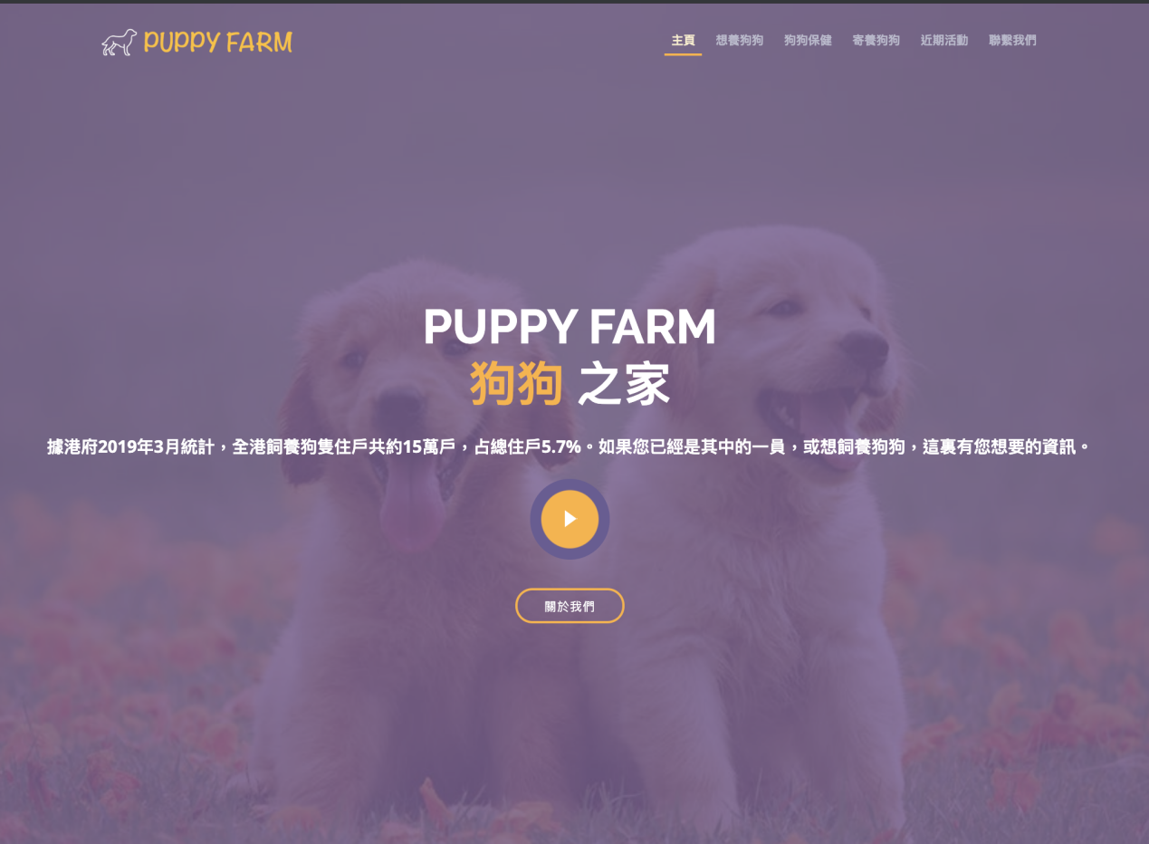

*Figure 17. Screenshot - Intro part*

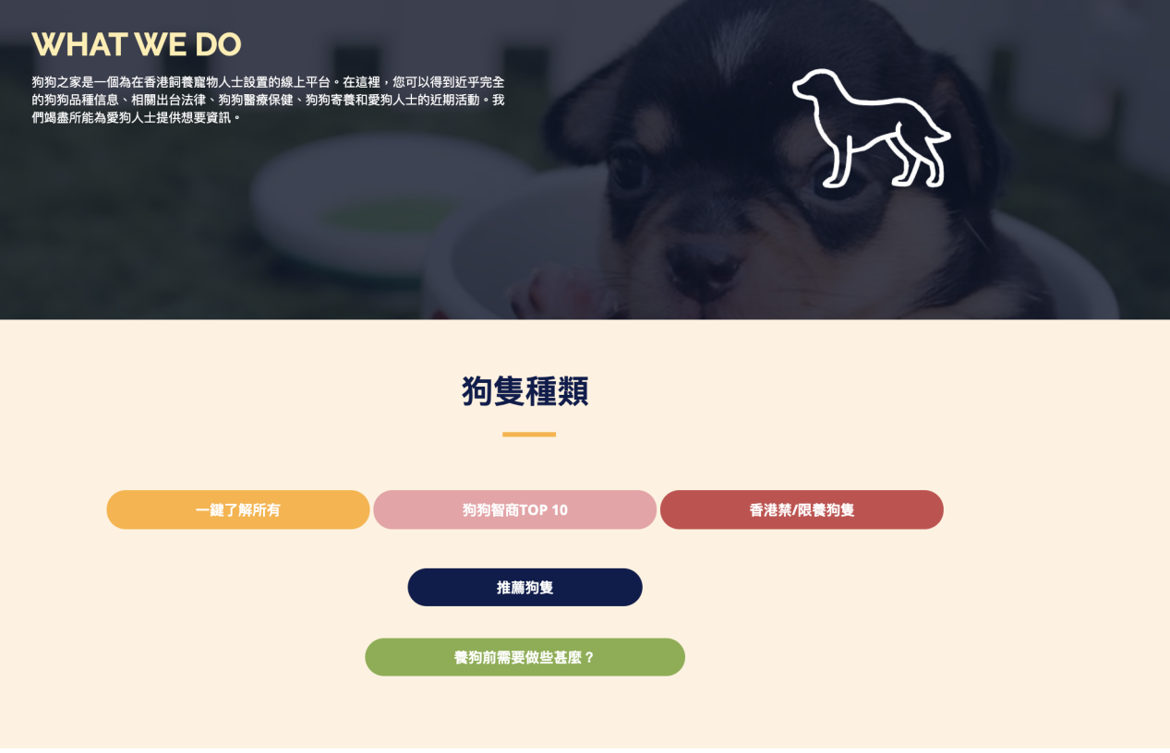***Figure 18. Screenshot - About & ‘Dog type’ section***

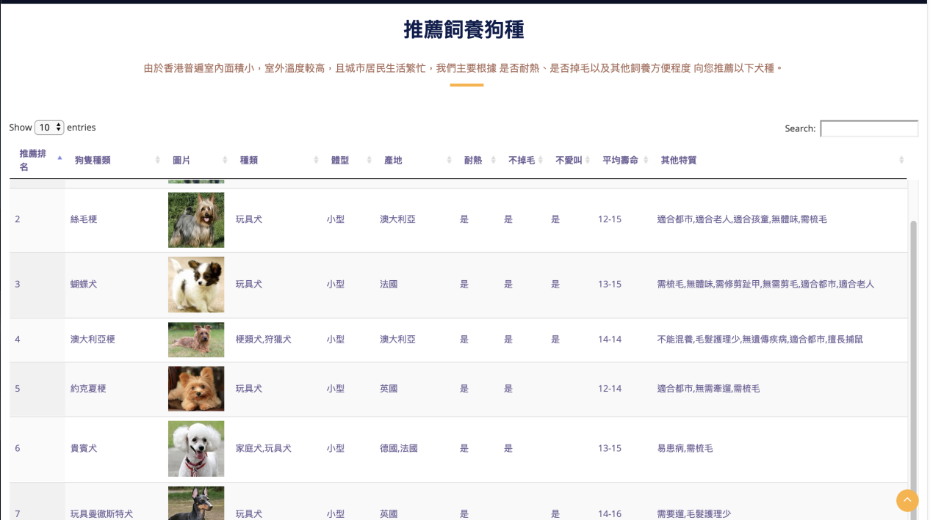

*Figure 19. Screenshot - ‘Recommendation’ part*

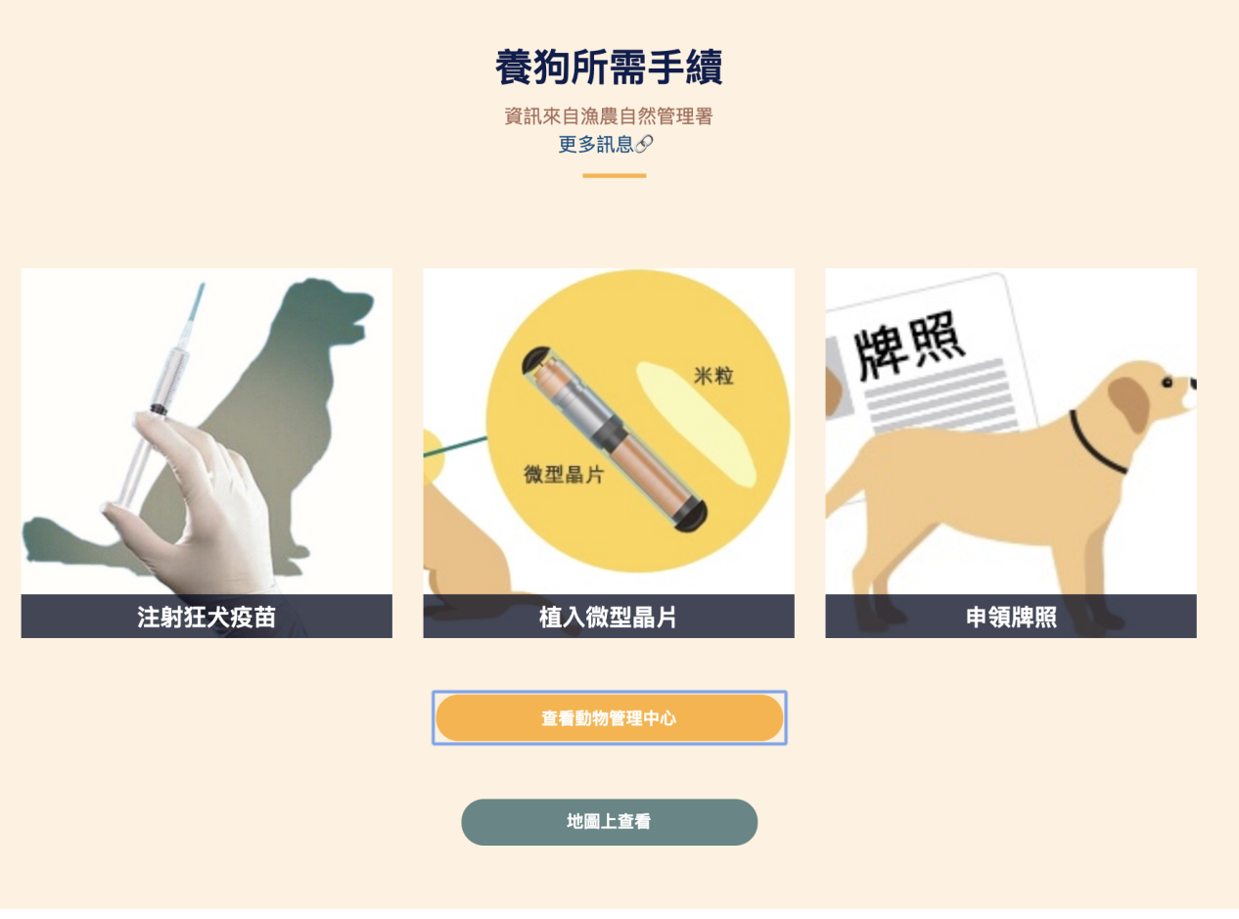

*Figure 20. Screenshot - ‘Procedures required’ section*

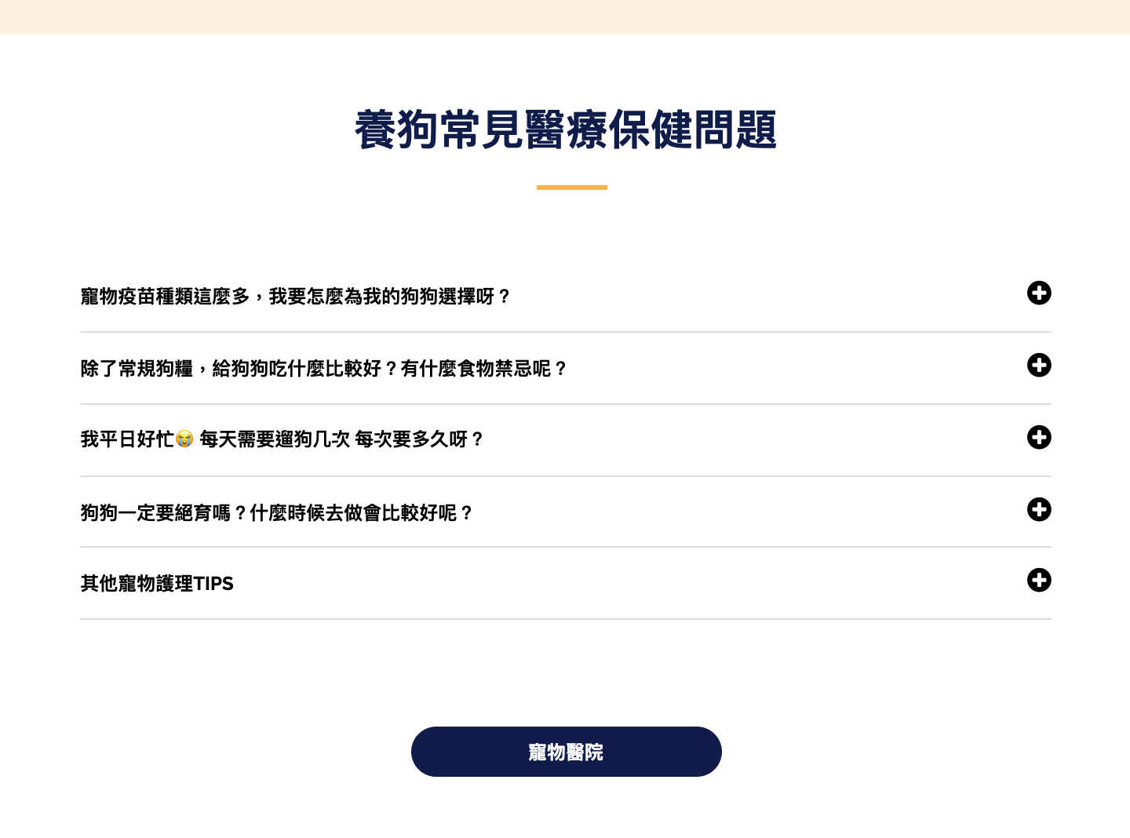

*Figure 21. Screenshot - ‘Tips on caring for dogs’ section*

**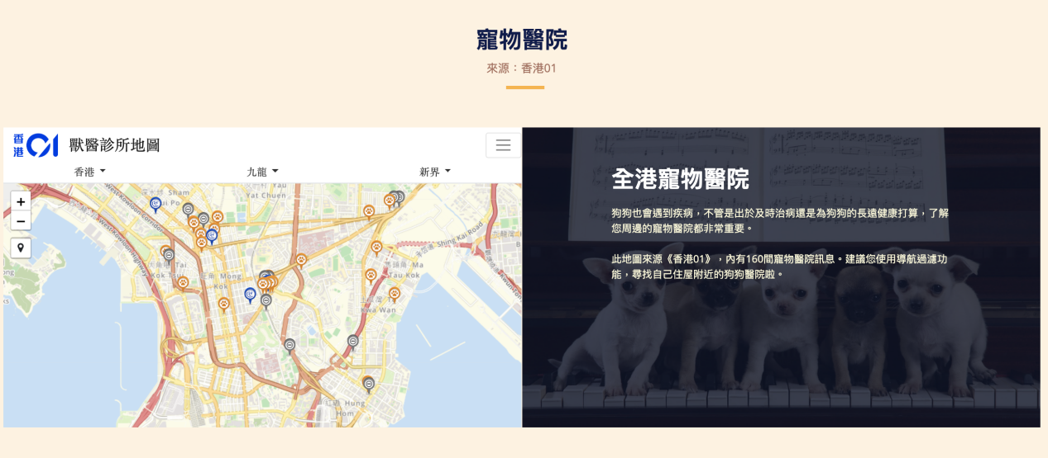***Figure 22. Screenshot - ‘Dog hospital’ section*

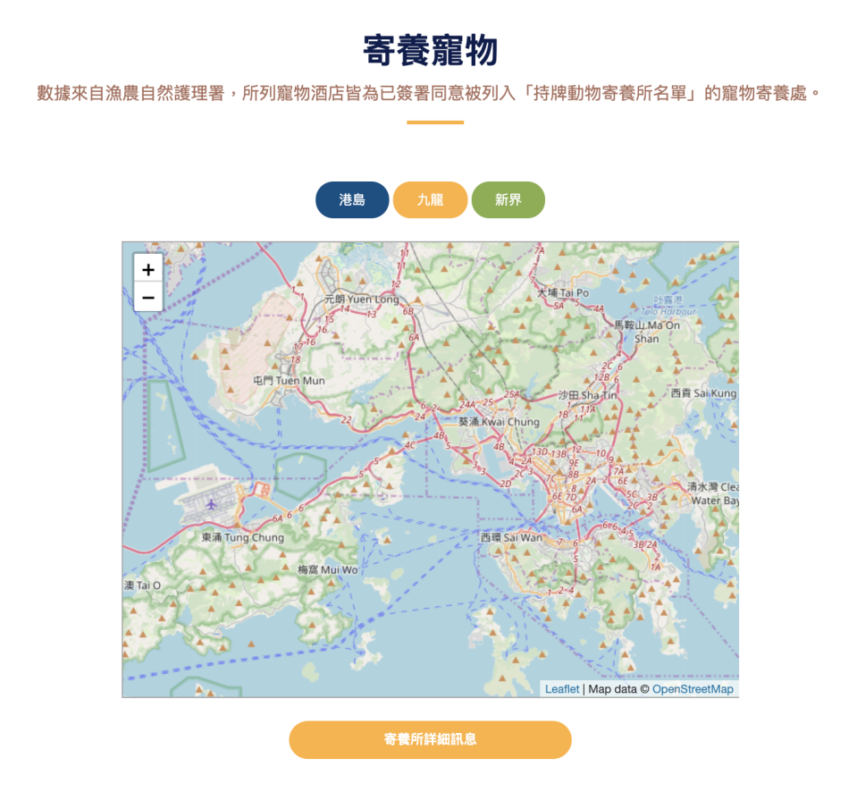

*Figure 23. ‘Dog hotel’ section*

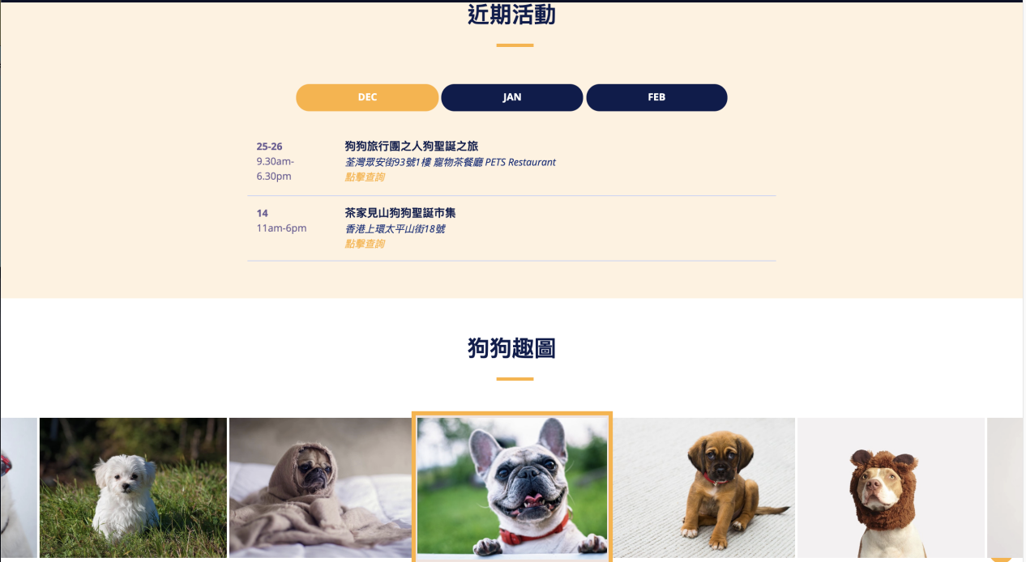

*Figure 24. ‘Upcoming events’ & Gallery section*

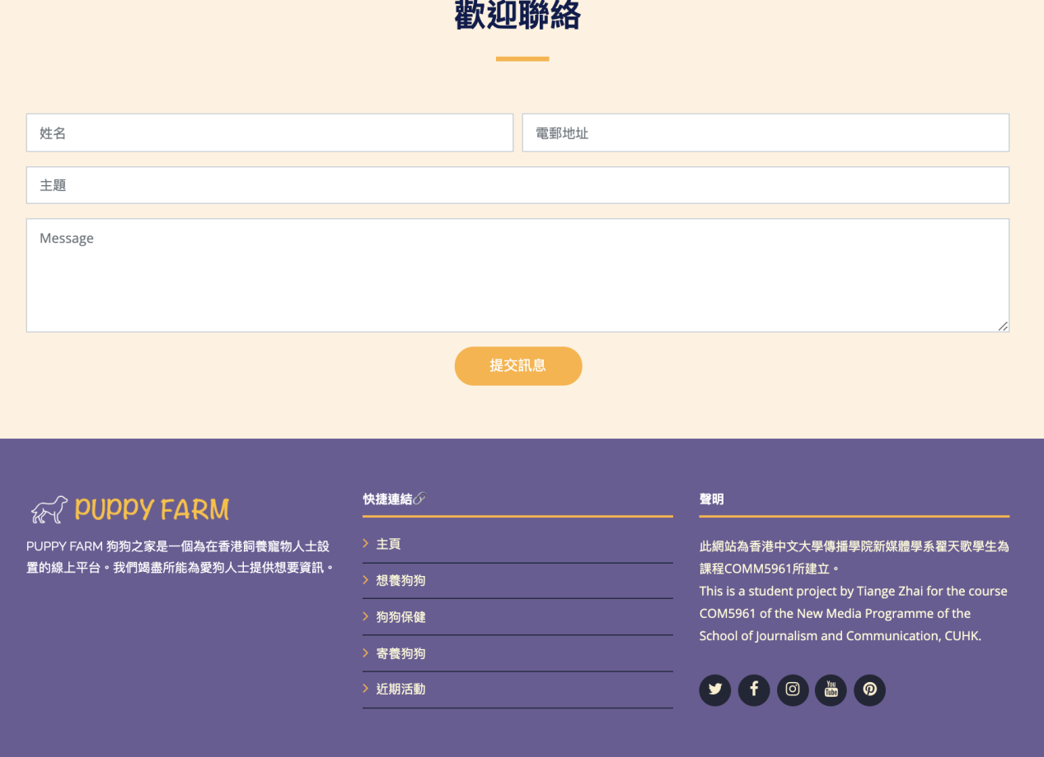

*Figure 25. ‘Contact’ section and Footer*

**A/B Testing**

An A/B testing was conducted for the quantitative usability analysis. I altered the size of the navigation bar, the header and the main introduction part, as I wondered if elements in a larger size would attract users and make them stay at the page for longer time. I also changed the background picture and colour to see users’ preferences. Below are the screenshots of the two versions. Figure 25 is the A version (original) with smaller font size, and Figure 26 shows the B version where elements are in a larger size.



*Figure 25. A/B Testing - A version*

**

*Figure 26. A/B Testing - B version*

After running the experiment for six days, certain data were collected to make decisions on which version to choose. I specifically measured the average duration time as I attempted to see which one would attract users to stay the page for a longer period. As shown in Figure 27, the original one was proved to outperform the variant.

*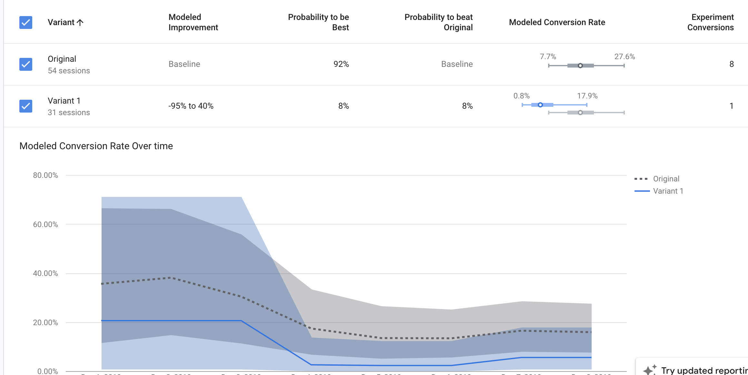Figure 27.A/B Test Results*

**Web Analytics**

After key stages of building the website have been established, I began to promote the Puppy Farm website among the target users. Google Analytics has been seen to be very crucial at this stage, as with its help, I have created a dashboard with eight metrics, as shown in Figure 28.

The dashboard visually demonstrates data concerning the user type, user by country/region, by browser, and by device category. Additionally, the dashboard also shows average session duration and pages/sessions viewed, the bounce rate, and the goal completion rate, which is to stay at the page for over three minutes (I tested it myself that to complete one task such as finding a dog hotel should have taken the user around three minutes).

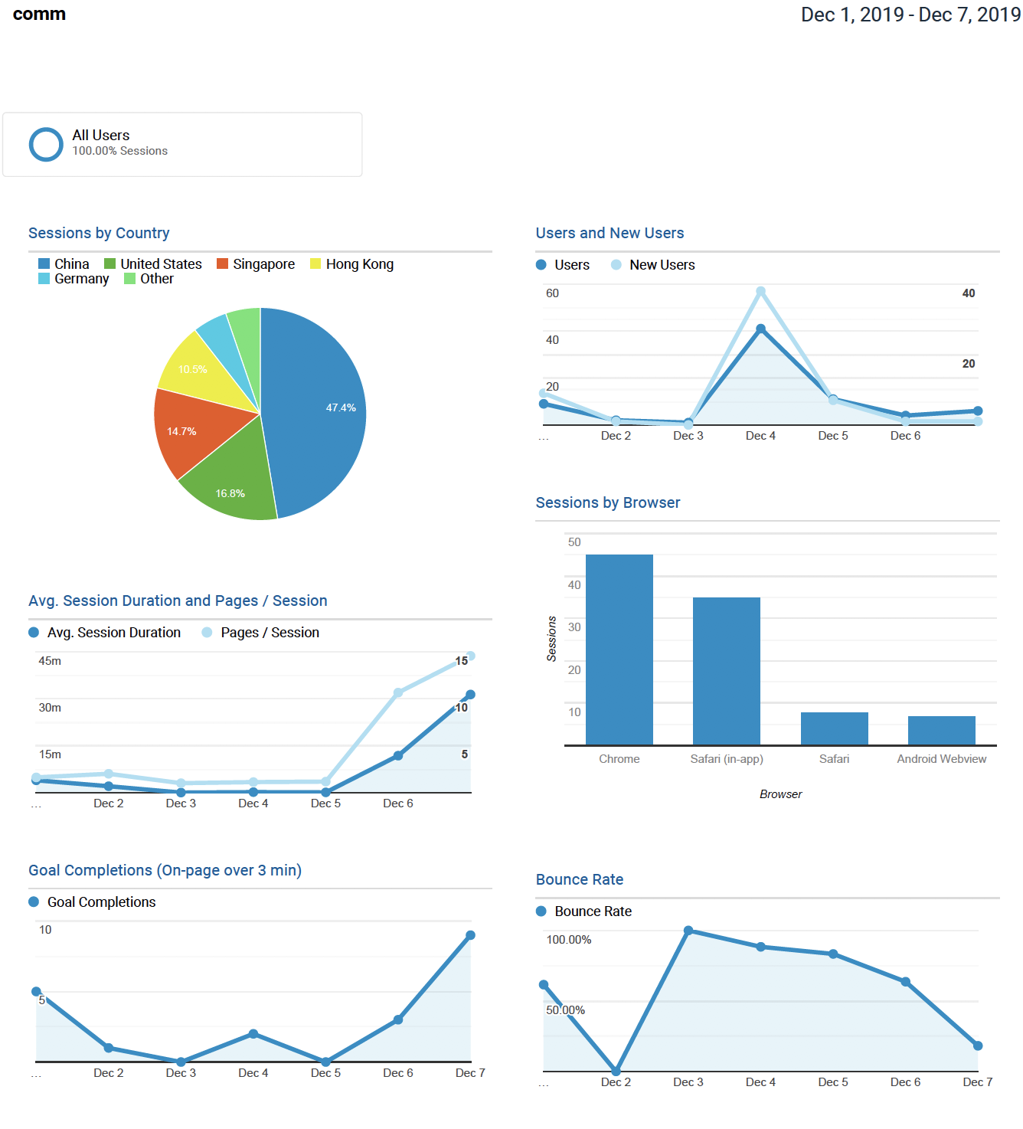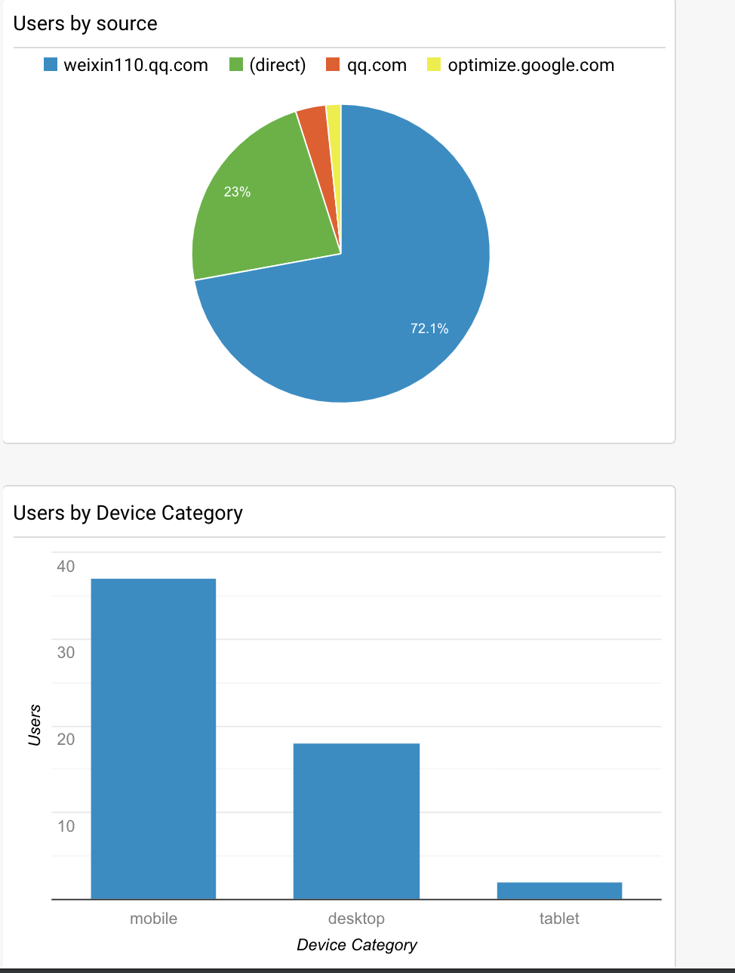

*Figure 28. Dashboard*

According to the report generated by Google Analytics, from 1 December to 7 December 2019, 52 have users paid visits to the website and 32.7% are returning users. Among them, less than half are from Mainland China, whereas only around 10% are from the target region - Hong Kong. This could be explained by the fact that I had to go back to Mainland for multiple reasons, meaning it was very hard to promote my website via Facebook and Instagram (although I did post my website link on these two sites). The users’ source has confirmed my thoughts as most users come from Wechat. However, the data also implies that this website could have more information for users from Mainland China, such as adding a section specifically catering for new movers to Hong Kong who bring their dogs together.

In terms of the ‘Users by Device Category’, the data shows that the vast majority of users used mobile devices to reach the website, following by desktop, accounting for approximately 31.6%. Only two users used tablets to view the site. The uncovered user habits of electronic devices suggest that the responsive design for mobile phones is very crucial.

Furthermore, it could be seen that the goal completion rate is 21.05%, meaning 20 sessions (combining both new and returning users) have stayed on the website for over three minutes. The bounce rate is 71.6% but faces a decline further on. According to the dashboard, there is a huge space for growth and development for the website.

**Conclusion**

It has been the first time that I established and coded a website entirely by myself. Although the whole process was very challenging - I switched the topic and started all over once - I have learnt much from the experience. The current site still have much space for improvement and is far from what I have imagined. For instance, I would like the map to integrate hotels, dog hospitals and other vital sites, to enable less repetitions in the web design. Additionally, the map could be more responsive such as including the detailed content (by clicking each marker users could view the detailed information in another column beside the map).

For further recommendations, the website could be developed into a platform for dog-owners to communicate with each other. Also, in the spectrum of social responsibility, Puppy Farm could cooperate with SCPA to hold a campaign calling for adoption of homeless dogs and standing against inhuman breeding methods. However, to accomplish such goals, the website is supposed to attain much more users’ data and influences among them.